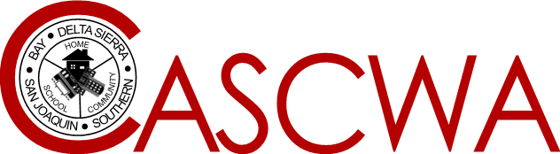

**California Association of Supervisors of Child Welfare and Attendance**

**LEGISLATIVE UPDATE**

**October 2020**

*Prepared by* Sherman Garnett

CASCWA Legislative Representatives

Dan Martin and Allen Dosty

Listed below is a brief synopsis of current legislation that has been introduced in the state Assembly and Senate. Please note that each bill listed has received legislative approval out of both the state Senate and Assembly by the legislative deadline to continue the legislative process and have been approved by governor. For a full description of each bill, you may access this information at: [www.senate.ca.gov](http://www.senate.ca.gov) or [www.assembly.ca.gov](http://www.assembly.ca.gov).

|  |
| --- |
| **ASSEMBLY BILLS** |
|  |

**AB 901-** Gipson-eliminates the authority of the county superintendent of schools to petition the juvenile court on behalf of a pupil in a county that has not elected to participate in a truancy mediation program. Additionally, deletes the authority of the juvenile court judge to adjudge a minor to be a ward of the court on the basis that the minor habitually refuses to obey the reasonable and proper orders or directions of school authorities.

**AB 908**-O’Donnell-Prohibits a work permit from being denied based upon the pupil’s grades, grade point average, or school attendance when the pupil’s school has been physically closed for an extended time due to a natural disaster, pandemic or other emergency.

**AB 1350-**Gonzalez-Authorizes a school district, county office of education or charter school to retroactively grant a high school diploma to a person who was in their senior year of high school during the 2019-2020 school year, in good academic standing and on track to graduate at the end of the 2019-2020 school year, and as of March 1, 2020 was unable to complete the statewide graduation requirements as a result of the COVID-19 crisis. .

**AB 1929**(Rubio)**-**Continues to authorize a county welfare agency to develop a system for internet-based reporting of child abuse and neglect.

**AB 2112** (Ramos)-Authorizes the State Department of Public Health to establish the Office of Suicide Prevention within the department to specifically provide strategic guidance to statewide and regional partners regarding best practices on suicide prevention and reporting to the legislature on progress to reduce rates of suicide.

**SENATE BILLS**

**SB 820-** Education Finance Bill- Numerous changes to Education Code including revision of Ed code 51512 ( Allowance to Video Recording of teacher during synchronous or asynchronous instruction without teacher and principal permission by the school district) and increased ADA credit for school districts that have demonstrated actual growth in enrollment.

**SB 823-** Juvenile Justice realignment- Requires several changes to current juvenile law including establishing a Juvenile Justice Realignment Block Grant to provide county-based custody, care and supervision of youth who are realigned from the Division of Juvenile Justice. Additionally requires any person whose case originated in juvenile court to remain in a county juvenile facility until they reach age 25 except as specified.

**SB 860**(Beall)-Requires the Foster Youth Services Coordinating Program to coordinate efforts to ensure completion of the Application for Federal Student Aid or the California Dream Act Application for foster youth pupils who are in grade 12.